A small e-commerce application:
This will be an e-commerce site, where some products will be there will all its detail information. Some customers will register themselves to the site or can choose the guest customer option to place an order.

Modules:
- Products
– Each product will come under a particular category. I.e there will be more than one categories under which some products will be there.
– Each product will have its price, description, options(colors etc), shipping price and product image.
- Cart
– The user will add some products to the cart and then it will move to the check out process to place the order.
- Customers
– The customer can be of two types(guest user or registered user.).

Pages:
- index page:
There will have all the categories listed in the left menu and on the page content will have some descriptions about the site and the products.
- Category page:
This will be the page where the user will be redirected after it clicks a category from the left menu. This page will contain all the associated products of the category displayed as thumbnails and having the price information.
- Product page:
– This is the page where the user will be redirected after it clicks a product thumbnail from the category page. This page will have the product image its descriptions and the price information, option I.e all the product related information.
– Also this page will display a for to add the product to cart. This form will have the product options as select boxes , a text box to enter quantity and a button called “Add to Cart”. On clicking the “Add to Cart” button, the product will be added to cart and the user will be redirect to the cart page.
- Cart page:
--This page will display all the products added to cart with an option to remove the product from cart or to update the product options or quantity. This page will also display the total product prices, total shipping prices and the total price as well.
– Along with it there will have a button called check out which will redirect the user to the check out page.
- Checkout page:
– When the user lands on the check out page it will show a login screen where the user will give its email id and password to place the order as a registered user(For register user please refer Registeration page). Also there will have a link, called “Order as guest user” on click of this link or in login, the check out form will appear having the products information displayed at the top of the form. If the user logs in as a registered user then pre-populate the check out form fields.
– Form fields in check out from:
Billing Address
  - First Name
  - Last Name
  - Email
  - Address
  - city, state, zip
Shipping Address: This will have the same fields as billing address(without email). A check box will be there beside the shipping address label. The label of that check box will read, “Check if billing address is same as shipping address.”.
  - Below address information, there will have a label called “Payment Details”. The fields are on the below image.

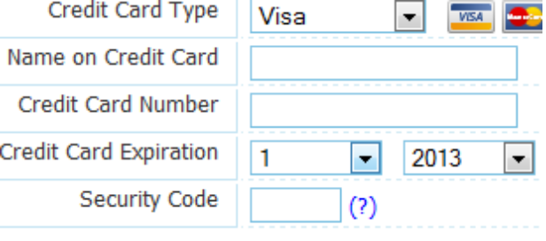
  - Finally there will be a button called 'Place Order'. On clicking of it it will save the all the order related information to DB and send a confirmation mail to the customer. After this it will redirect to the Order receipt page.

Order Receipt page:
  - This will show all the details about the order, which includes the order products the customet information entered, the price information etc.

Registeration page:
  - To navigate to this page, there will be a link below the category links in the left menu. This page will have the same fields as the check out page address information with the password and confirm password fields.
Note: All the pages will have the left menu and while login as registered customer it will only take the billing email into consideration.

Coding Conventions:
1. Scope Specifier: small case
2. Name of variables and user defined functions: camel casing
3. Predefined functions: pascal casing
4. file names: small casing and hiphen separated
5. folder names: small casing and hiphen separated

